**Program Three Part One**

//summary: This program takes 3 edges from a triangle and finds the perimeter. It also checks

// to make sure that one edge is not bigger than the sum of the other two edges

//name: Jenna Wolf

//class: Fundamentals of Programming, CS155 - 01

//instructor: Dr. Art Kazmierczak

//date: 9/5/2023

import java.util.Scanner; //allows inputs to be made

public class Main

{

public static void main(String[] args)

{

Scanner input = new Scanner(System.in); //labels input as input

double edge1, edge2, edge3, per, temp; //holds the data for each double variable

//takes in the data for all three edges

System.out.println("Please enter the first edge of your triangle: ");

edge1 = input.nextDouble();

System.out.println("Please enter the second edge of your triangle: ");

edge2 = input.nextDouble();

System.out.println("Please enter the third edge of your triangle: ");

edge3 = input.nextDouble();

//checks to see if the value for one edge is bigger than the value of the other two edges combined

if(edge1 > (edge2 + edge3) || edge2 > (edge1 + edge3) || edge3 > (edge1 + edge2))

{

//prints an error message

System.out.println("You entered invalid amounts! (one edge cannot be more than the sum of the other two edges!)");

System.out.println("Please try again!");

}

else

{

//adds all the edges together and displays the perimeter

per = edge1 + edge2 + edge3;

System.out.println("The perimeter of a triangle with edges of " + edge1 + ", " + edge2 + ", and " + edge3 + " is " + per);

}

}

}

Output 1:

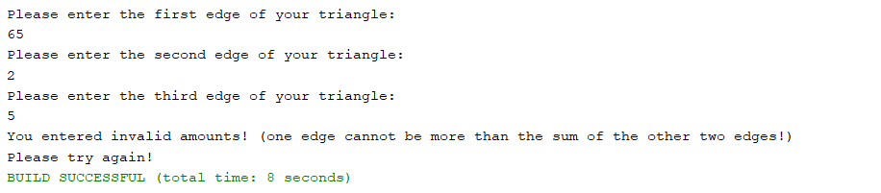

Output 2:

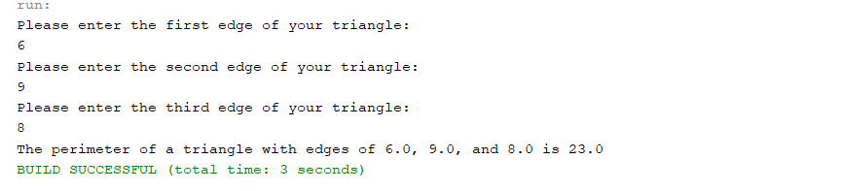

**Program Three Part Two**

//summary: This program allows the user to choose weather they want to convert Us dollars to Chinease RMB or vice versa.

// it then converts said currencys based on the users inputs. Also makes sure inputs are correct.

//name: Jenna Wolf

//class: Fundamentals of Programming, CS155 - 01

//instructor: Dr. Art Kazmierczak

//date: 9/5/2023

import java.util.Scanner; //allows inputs to be made

public class Main

{

public static void main(String[] args)

{

Scanner input = new Scanner(System.in); //labels input as input

int choice; //holds the data for choice

double usDol, chiRMB; //holds the data for each double variable

//prints a message and takes in the users input

System.out.println("Please enter 0 to convert US dollars to Chinease RMB and 1 to convert Chinease RMB to US dolalrs");

choice = input.nextInt();

//performs different actions depending on the users input

if(choice == 0)

{

//prints a message and takes the users input

System.out.println("Please enter the US dollar amount you would like to convert to Chinease RMB");

usDol = input.nextDouble();

chiRMB = usDol * 6.81; //converts US Dollar to Chinease RMB

//displays the converted amount

System.out.println("With $" + usDol + ", you will have " + chiRMB + " yuan");

}

else if(choice == 1)

{

//prints a message and takes the users input

System.out.println("Please enter the Chinease RMB amount you would like to convert to US dollars");

chiRMB = input.nextDouble();

usDol = chiRMB / 6.81; //converts Chinease RMB to US dollars

//displays the converted amount

System.out.println("With " + chiRMB + " yuan, you will have $" + usDol);

}

else

System.out.println("You entered a invalid choice! Please try again!"); //displays an error message

}

}

Output 1:

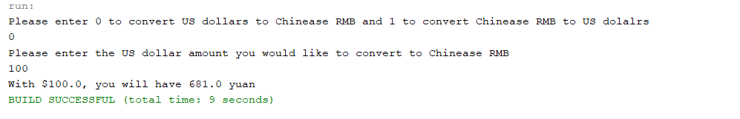

Output 2:

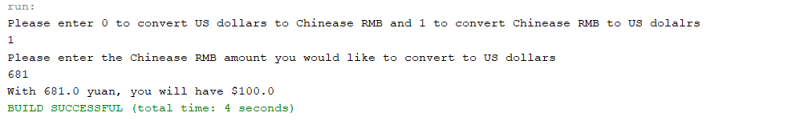

Output 3:

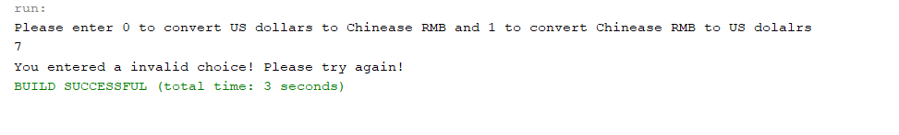

**Program Three Part Three**

//summary: This program takes the price and weight of two boxes of rice and finds which one is the better deal.

//name: Jenna Wolf

//class: Fundamentals of Programming, CS155 - 01

//instructor: Dr. Art Kazmierczak

//date: 9/5/2023

import java.util.Scanner; //allows inputs to be made

public class Main

{

public static void main(String[] args)

{

Scanner input = new Scanner(System.in); //labels input as input

double weight1, weight2, price1, price2, box1, box2; //holds the data for each double variable

//prints a message and takes in the users input for the first box of rice

System.out.println("Please enter the weight and price for your first package of rice");

weight1 = input.nextDouble();

price1 = input.nextDouble();

//prints a message and takes in the users input for the second box of rice

System.out.println("Please enter the weight and price for your second package of rice");

weight2 = input.nextDouble();

price2 = input.nextDouble();

box1 = price1 / weight1; //finds the price per pound of box 1

box2 = price2 / weight2; //finds the price per pound of box 2

//displays a different message depending on the values of box 1 and box 2

if(box1 < box2)

System.out.println("The first package of rice is the better deal"); //displayed if box 1 is lower in cost

else if(box1 == box2)

System.out.println("The packages of rice are the same price"); //dispalyed if boxes are even deals

else

System.out.println("The second package of rice is the better deal"); //displayed if box 2 is lower in cost

}

}

Output 1:

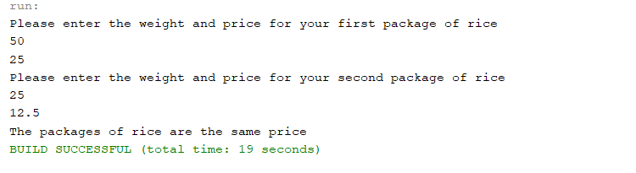

Output 2:

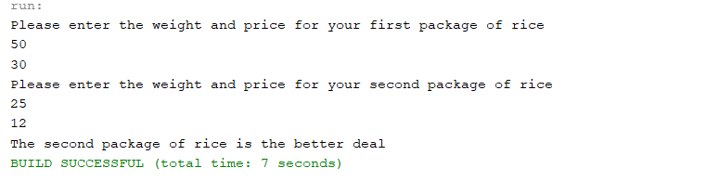

Output 3:

